How to: Deploying GitOps Pipeline on K8S hosted on vCluster

When you’re building applications on Kubernetes, GitOps has become a thing, or make that should be a thing, a big thing for that matter.
GitOps is a way to manage IT infrastructure and software using Git as the single source of truth. Instead of running manual scripts to update servers, you store all system configurations in code. Automated agents watch this code and update live environments to match
The Core Principles
- Declarative State: You describe the end goal (e.g., "I need three running web servers") rather than the steps to get there.
- Version Control: All changes go through version-controlled Pull Requests (PRs) or Merge Requests (MRs). This allows teams to review and approve updates just like regular software code.
- Automated Synchronization: Specialized software agents monitor the Git repository for updates. When they see a change, they instantly apply it to your environment.
- Continuous Reconciliation: The agents do not just deploy once. They constantly check the live system against Git. If the live system drifts, the agent fixes it
In our example below, we’re a developer working locally on his laptop (although everything we’re building below can be deployed exactly as defined onto a larger team shared deployment also). Committing his changes into the project Github repo.
We will be configuring a GitOps pipeline using Github Actions to “build” our Docker container after which we will push the new container image into our hub.docker.com account.
IMPORTANT:
As part of this “build” process Github Actions also updates our k8s/deployment.yml file with the image tag assigned to the image when it was built and pushed into our container registry hosted in hub.docker.com. The update is done by replacing the “placeholder” variable next to image: tag (line 21). This is an important concept to remember.
We will pre-configure our Kubernetes cluster with ArgoCD and define a “project”, which will in turn monitor our Github project, specifically the above mentioned k8s/deployment.yml file.
Once it picks up that the file has been changed then ArgoCD executes the steps as per our argocd-app.yml file, which deploys/redeploys our project as defined in k8s/deployment.yml onto our Kubernetes cluster hosted on vCluster.
Note:ArgoCD together with Github Actions can also be configured to “push” the changes onto a destination cluster. For myself, working in the financial industry, and as we’re using Github Actions, which reside outside our network the pull is a more secure pattern.
A Push pattern could very likely be preferred for application deployed in say AWS, where the ECR (Elastic Container Registry) and EKS (Elastic Kubernetes Cluster) is all hosted in a secured account.

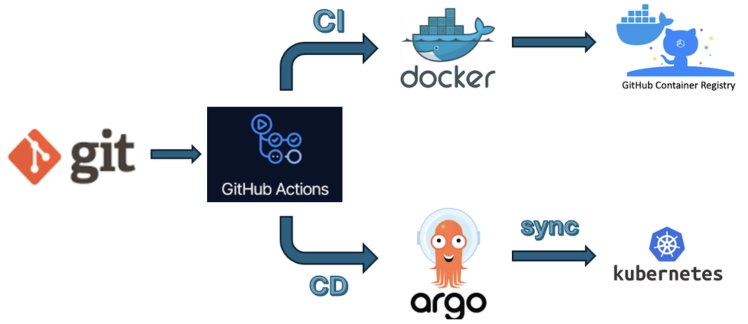

No cloud account required. No VMs. Just Docker and a few commands and we have a fully functional Kubernetes development environment with an automated CI/CD deployment pipeline.
In our previous editions we built a complete monitoring stack for our environment, also commonly referred to as the metrics collection component of an Observability stack (Part 1), but a Observability is the combination of metrics and log, so in Part 2 we added an Log Analytics based on Elastsearch.
We are expanding our development environment in this blog, maturing our all in one local development environment so as to maximize developer productivity by providing them with an environment representing expected production as close as possible.
All source code (for this blog) is available at georgelza/gitops-pipeline.

Why vCluster for This?
vCluster with the Docker driver gives you a multi-node Kubernetes cluster running entirely in Docker containers. For this project, that means a control plane and three worker nodes enough capacity to run the full observability stack alongside demo workloads all created with a single command:

vcluster create my-pipeline -f vcluster.yaml
The vcluster.yaml configures a 3-worker-node cluster:
controlPlane:
distro:
k8s:
version: "v1.36.0"
experimental:
docker:
nodes:
- name: "worker-1"
- name: "worker-2"
- name: "worker-3"
That’s it. In under a minute, you have a fully functional Kubernetes cluster with multiple nodes, ready to host real workloads. When you’re done for the day, vcluster pause my-pipeline frees up resources. vcluster resume my-pipeline picks up right where you left off.

What We’re Deploying
Here’s the full stack:
Component | What It Does
ArgoCD | Argo CD is a declarative, GitOps continuous delivery tool for Kubernetes.
Github Repo | A GitHub repository (commonly shortened to "repo") is essentially a digital project folder hosted on GitHub that stores your code, assets, and documentation
Github Runner | A GitHub runner is the execution engine or compute instance that runs the jobs defined in your GitHub Actions automation and CI/CD pipelines. Think of it as a virtual or physical server that wakes up when triggered, clones your code, installs your required packages, and runs tasks like automated testing or deployment.
Container Repo | A Docker repository is a collection of related Docker container images organized by "tags" that represent different versions of the same application. It works like a GitHub repository, but instead of hosting raw source code, it stores pre-packaged, ready-to-run software builds

Demo Applications
We will be using a very simple FastAPI web application based on Python (app.py).
import os
from fastapi import FastAPI
app = FastAPI(title="K8s-GitOps-Demo")
@app.get("/")
def read_root():
return {
"status": "healthy",
"engine": "ArgoCD Pull Model",
"message": "Hello from a secure GitOps workflow!"
}
@app.get("/healthz")
def health_check():
return {"status": "OK"}

Deploying the Stack
The deployment follows a specific order since components depend on each other:
- Create our Kubernetes Cluster
- Create app and argocd namespaces
- Deploy ArgoCD stack onto Kubernetes Cluster
- Create Docker project
  - Configure Docker Personal Access Token (Read/Write)
- Create Github project
  - Configure Docker access secrets
- Upload/push our project from the local project folder to Github repository.

For the complete step-by-step walkthrough, see README.md and BUILD.md

The Bigger Picture
This project is part of a series building up a complete local Kubernetes development environment:
- Running K8s Locally with vCluster Inside Docker — The foundation: setting up vCluster as a local dev environment
- Web Apps on vCluster with Traefik and Ingress — Deploying applications with proper ingress routing
- Observability Stack, Part 1 — Metrics, dashboards, and long-term storage
- Observability Stack, Part 2 — Log analytics with Elasticsearch
- GitOps Pipeline (this Blog) — GitOps Pipeline configured using ArgoCD
By the end of the series, you have a local environment with application hosting, ingress routing, metrics collection, dashboarding, alerting, long-term metric storage, and log analytics. Now configured with an automated CI/CD pipeline root in Github.
That’s a genuinely useful development platform — and it all runs on your laptop.

Deployment
The deployment has been divided into 2 sections, Core deployment which is our Kubernetes cluster (including ArgoCD) and the defining of our GitOps pipeline in Github using required yaml files as part of our project. Let’s get started.

Core Deployment:

(Note, you can skip the core deployment if you still have it running from the previous blog, the GitOps stack fits nicely on what we previously built).

git clone
https://github.com/georgelza/gitops-pipeline.git
cd gitops-pipeline

First, a screenshot showing what we are starting with:

The below steps/screenshots are basically our output from the steps as per BUILD.md.

Docker ps

sudo vcluster create my-pipeline --values vcluster.yaml

controlPlane:
# Configure the backing store for vCluster's data
backingStore: # Enterprise feature - requires license
etcd:
embedded:
enabled: true # Run etcd inside the vCluster pod
experimental:
docker:
nodes:
- name: "worker-1"
volumes:
- "./data/vc:/data"
env:
- "NODE_ROLE=worker"
- name: "worker-2"
volumes:
- "./data/vc:/data"
env:
- "NODE_ROLE=worker"
- name: "worker-3"
volumes:
- "./data/vc:/data"
env:
- "NODE_ROLE=worker"

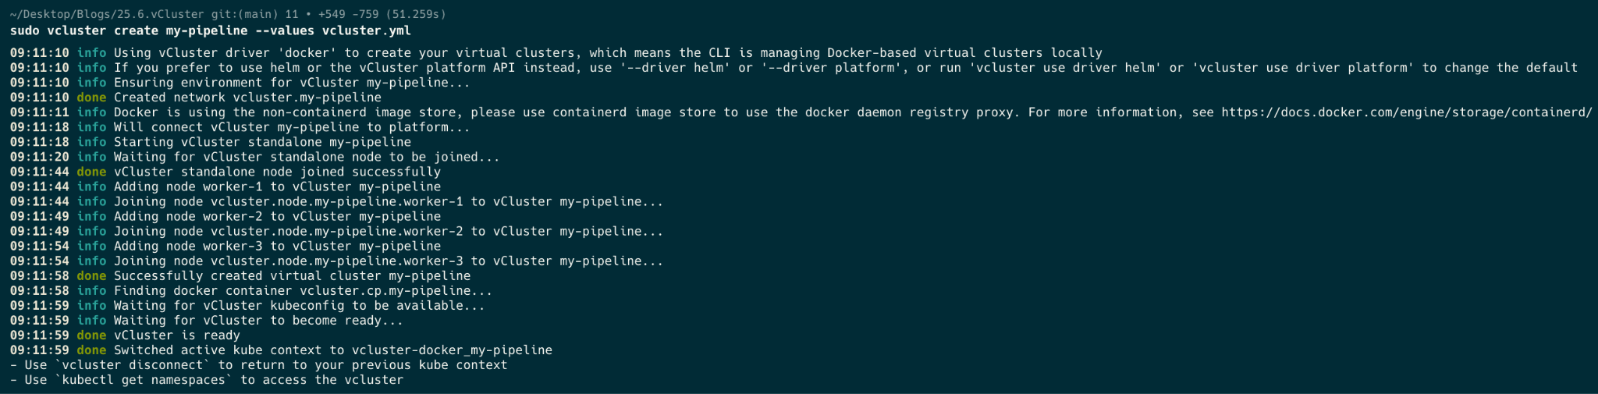

Now a docker ps after we’ve created our cluster.
docker ps

kubectl get nodes
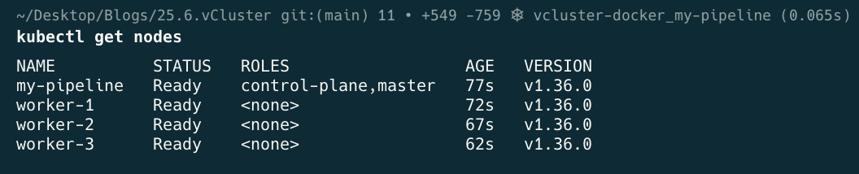

kubectl get namespaces
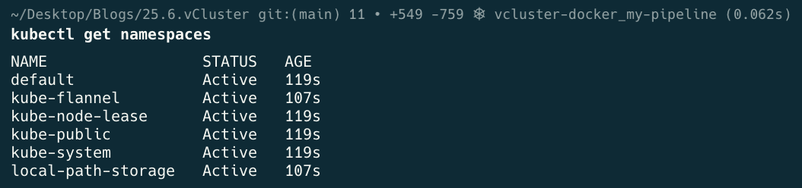

Lets quickly create our 2 namespaces that will be utilised.
cat <<EOF | kubectl apply -f -
apiVersion: v1
kind: Namespace
metadata:
name: app
EOF

cat <<EOF | kubectl apply -f -
apiVersion: v1
kind: Namespace
metadata:
name: argocd
EOF
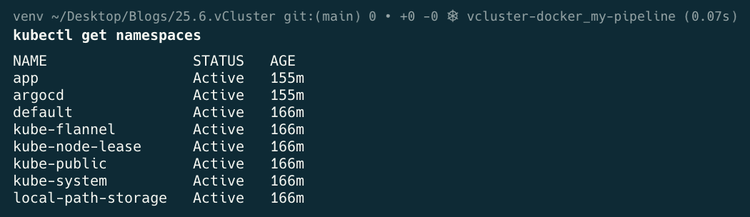

kubectl label node worker-1 worker-2 worker-3 node-role.kubernetes.io/worker=worker
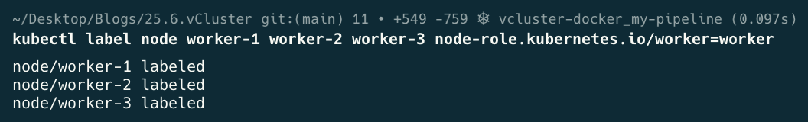

kubectl get nodes
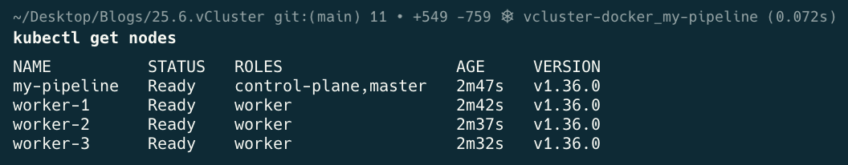

GitOps Pipeline Deployment:

At this point we will now execute the steps as per GITOPS.md.

The below steps are as per step #3 in the GITOPS.md document.

Phase 1

# 1. Deploy stable ArgoCD infrastructure components
kubectl -n argocd create -f https://raw.githubusercontent.com/argoproj/argo-cd/stable/manifests/install.yaml

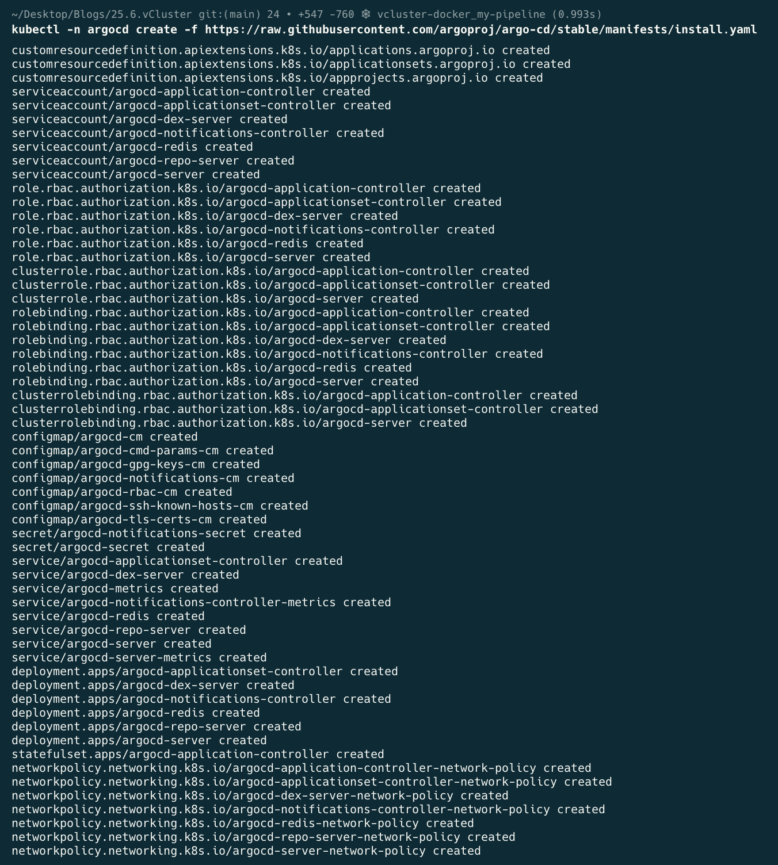

# 2. Block and watch until all operators show "Running"
kubectl get pods -n argocd -w
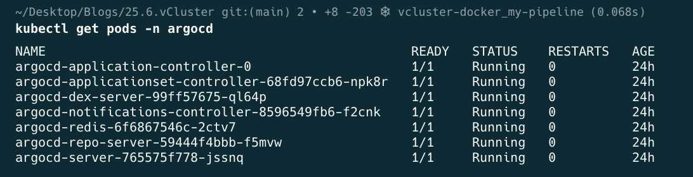

Phase 2

First we need to create a project in hub.docker.com. Once we have a project we create an access token, also referred to as a Personal Access Token.

Phase 3

Once we have the above container project created and the access key (Personal Access Token) created we configure Github with Secrets and variables/Actions.

This grants GitHub with Read/Write access to create a new container in the project.

Think of GitHub as the builder that needs keys to enter your warehouse (Docker Hub). If you paste these keys directly into your code, anyone who looks at your repository can steal them. Instead, you put them into GitHub's secure vault called Actions Secrets.

Here is exactly what you do, step-by-step, inside your web browser.

Step 0: Register/Create new repository, for our blog we're using gitops-pipeline

Step 1: Open Your Repository's Vault

- Open your web browser and go to GitHub.
- Navigate to your specific code repository for this project.
- Look at the horizontal menu tabs near the top (Code, Issues, Pull Requests...). Click on the Settings tab (it has a gear icon ⚙️).

Step 2: Navigate to Actions Secrets

- On the left-hand sidebar, scroll down until you see the Security and quality.
- Click on secrets and variables and variables to expand it, then click on Actions.

You are now in the secure vault workspace.

Step 3: Add Your Docker Hub Username

- Click the green button at the Right/middle that says New repository secret.
- In the Name field, type exactly this: DOCKERHUB_USERNAME
- In the Secret field, type your actual Docker Hub username (the name you use to log into hub.docker.com).
- Click the green Add secret button.

Step 4: Add Your Docker Hub Key (The Token)

- Click that green *New repository secret* button one more time.

- In the Name field, type exactly this: DOCKERHUB_TOKEN
- In the Secret field, paste the complete personal access token string you copied from Docker Hub.
- Click the green Add secret button.

What Did We Just Accomplish?

By doing this, you have securely wired the two platforms together without hardcoding sensitive details.

When you push your code, the GitHub-hosted runner spins up and runs the automated blueprint file (.github/workflows/ci.yml). When it reaches these lines:

- name: Log in to Docker Hub
uses: docker/login-action@v3
with:
username: ${{ secrets.DOCKERHUB_USERNAME }}
password: ${{ secrets.DOCKERHUB_TOKEN }}

The runner automatically reaches into the secure vault, grabs your username and token on the fly, logs into Docker Hub, pushes your compiled Python container, and vanishes—keeping your credentials entirely secure.

.github/workflows/ci.yml

name: CI Build and Manifest Update
on:
push:
branches:
- main
paths-ignore:
- 'deployment.yml' # <-- Updated from 'k8s/**'
jobs:
build-and-patch:
runs-on: ubuntu-latest
permissions:
contents: write # Allows pushing the updated YAML tag back to Git
steps:
- name: Checkout Source Code
uses: actions/checkout@v4
with:
fetch-depth: 0 # Fetches full history for proper Git tracking
- name: Set up Docker Buildx
uses: docker/setup-buildx-action@v3
- name: Log in to Docker Hub
uses: docker/login-action@v3
with:
username: ${{ secrets.DOCKERHUB_USERNAME }}
password: ${{ secrets.DOCKERHUB_TOKEN }}
- name: Build and Push Docker Image
uses: docker/build-push-action@v5
with:
context: .
push: true
# Instructs Buildx to compile for both standard x86 and ARM servers
platforms: linux/amd64,linux/arm64
tags: |
${{ secrets.DOCKERHUB_USERNAME }}/python-fastapi-app:latest
${{ secrets.DOCKERHUB_USERNAME }}/python-fastapi-app:${{ github.sha }}
cache-from: type=gha
cache-to: type=gha,mode=max
- name: Update Manifest Image Tag
run: |
# 1. Target the file inside your k8s/ folder matching your exact .yml extension
sed -i -E "s|(image: ${{ secrets.DOCKERHUB_USERNAME }}/python-fastapi-app:).*|\1${{ github.sha }}|" k8s/deployment.yml
# 2. Configure a Git Identity
git config user.name "github-actions[bot]"
git config user.email "github-actions[bot]@users.noreply.github.com"
# 3. Track and commit the exact file from the k8s directory path
git add k8s/deployment.yml
git commit -m "chore: auto-update deployment image tag to ${{ github.sha }} [skip ci]"
git push

Now that these secrets are saved, you are ready to commit and push your files from your local workstation to trigger the initial container build.

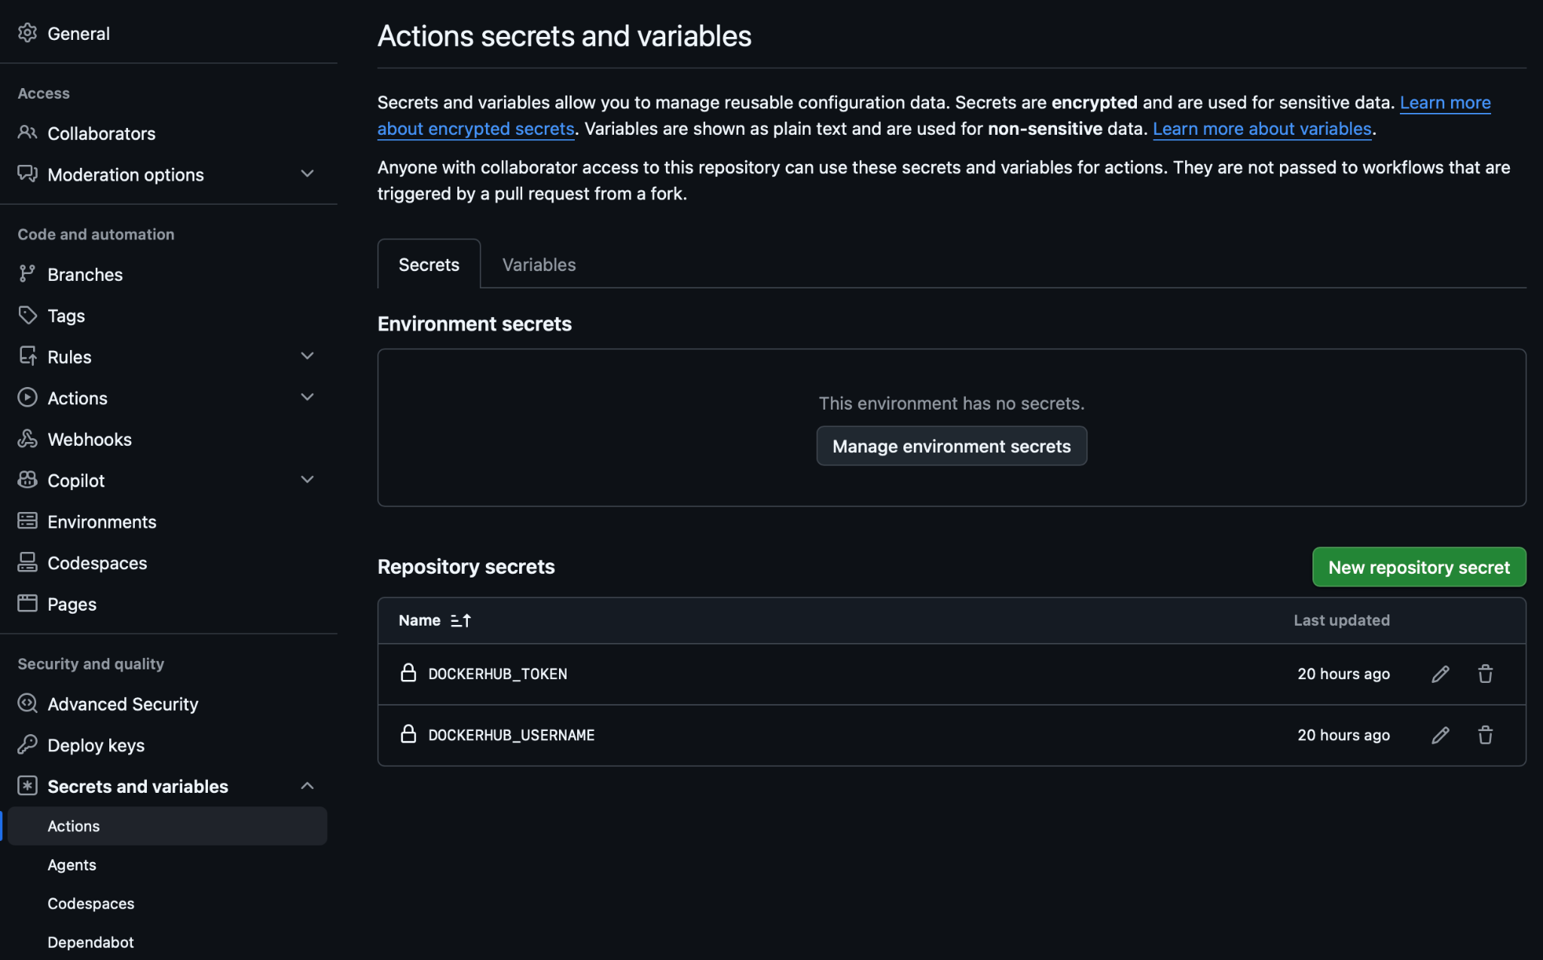

At this point we have completed all the pre-requisites.

Phase 4

Provision the Runner & Push Baseline (From Workstation)

Now, push your local folder setup to GitHub. This triggers the GitHub-hosted runner to provision its computing workspace, build the image, and output the tracking tag.

git add .
git commit -m "ci: establish core framework baseline"
git push origin main

⏳ Pause Strategy: Open your GitHub repository web browser interface and click on the Actions tab. Wait until the active runner job executes completely and displays a green checkmark. If you inspect your k8s/deployment.yml file in the GitHub UI, you will see that the text :placeholder has been updated to your long Git commit SHA string.

Phase 5

Wire the Cluster to Pull Manifests (On Cluster Control Plane)

With the correct image tag committed back to your Git repository, instruct ArgoCD to monitor the repository and deploy the resources to your targeted namespace. Run this command on your cluster terminal:

kubectl apply -f argocd-app.yml

apiVersion: argoproj.io/v1alpha1
kind: Application
metadata:
name: python-gitops-pipeline
namespace: argocd # Directs the declaration to the ArgoCD controller space
spec:
project: default
source:
repoURL: 'https://github.com/georgelza/gitops-pipeline.git'
targetRevision: main
path: k8s # Instructs ArgoCD to track your manifests inside the k8s folder
destination:
server: 'https://kubernetes.default.svc' # Instructs it to deploy to the local cluster
namespace: app # Directs deployment straight into your isolated 'app' namespace
syncPolicy:
automated:
prune: true # Automatically deletes K8s resources if you remove them from Git
selfHeal: true # Overwrites manual cluster overrides to keep Git as the single source of truth

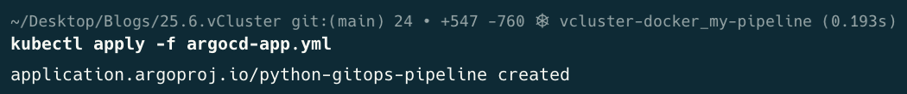

ArgoCD instantly reads the k8s/deployment.yml file from your Github repository, translates the requirements, handles the target definitions, and sets up your application inside the app namespace.

apiVersion: apps/v1
kind: Deployment
metadata:
name: python-app-deployment
namespace: app
labels:
app: python-fastapi
spec:
replicas: 2
selector:
matchLabels:
app: python-fastapi
template:
metadata:
labels:
app: python-fastapi
spec:
containers:
- name: fastapi-app
image: georgelza/python-fastapi-app:9d78760ac56e42d773290eee71769ed4a40c3d70
imagePullPolicy: Always
ports:
- containerPort: 8000
livenessProbe:
httpGet:
path: /healthz
port: 8000
initialDelaySeconds: 5
readinessProbe:
httpGet:
path: /healthz
port: 8000
initialDelaySeconds: 5
---
apiVersion: v1
kind: Service
metadata:
name: python-app-service
namespace: app
spec:
selector:
app: python-fastapi
ports:
- protocol: TCP
port: 80
targetPort: 8000
type: NodePort

Verification

Verify that your application has been safely pulled and initiated within its designated workspace:

kubectl get deployments,services,pods -n app -o wide

Output:

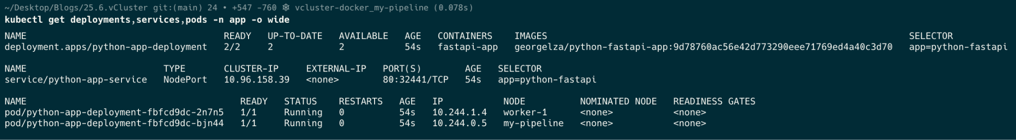

5. Future Redeploy Action-Trigger Loop

For every future code alteration or deployment update, you do not need to repeat any of the steps above. The automated loops trigger natively when a commit lands:

You push an update to app.py from your local workspace:

git add app.py
git commit -m "feat: upgrade runtime message block"
git push origin main

Access our Application:

To access your newly deployed Python FastAPI application from your workstation, you have two clear options based on your NodePort configuration.

Option 1: Access via NodePort (Direct Cluster Routing)

Your python-app-service manifest correctly configured a NodePort service. Looking at your kubectl get output:

service/python-app-service NodePort 10.99.36.33 <none> 80:30449/TCP

Kubernetes has opened port 30449 across every single physical node in your cluster.

To access the app directly, find the host IP address of any of your cluster nodes (such as the machine hosting worker-2 or worker-3) and navigate to it in your browser on that high port:

http://<ANY_CLUSTER_NODE_IP>:30449/

Option 2: Use a kubectl Port-Forward Tunnel (Recommended for Testing)

If you want to map the cluster application specifically to your workstation's localhost:8000 interface for convenient local testing, you can instruct kubectl to open a secure, bidirectional network tunnel from your desktop straight to the service.

Run this command in a separate terminal window on your workstation:

kubectl port-forward svc/python-app-service -n app 8080:80

What this does:

This binds your workstation's local port 8000 directly to the cluster service's incoming port 80.
Once that command is running, open your web browser and navigate to:

NOW, you may ask, but our app is exposed on port 8000 in the container, see the Dockerfile, should we not be using this port?

Our configuration is actually completely correct as it stands, and you do not need to change the application's internal container port (8000).

In your Kubernetes manifest, you created a translation layer using the Service definition. Let's look at how the traffic flows:

ports:
- protocol: TCP
port: 80 # <-- The Service's entry port inside the cluster
targetPort: 8000 # <-- The port the Service forwards to inside the container

Because of this mapping, the Service listens on port 80 inside the cluster network and automatically shifts the traffic to port 8000 inside your Python container.

Why Option 2 (kubectl port-forward) works with your setup:

When you run a port-forward command, you specify LOCAL_PORT:CLUSTER_SERVICE_PORT. Since your service is listening on port 80, your command should target port 80 like this:

kubectl port-forward svc/python-app-service -n app 8080:80

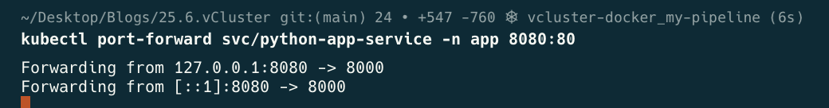

In a new terminal

curl -i http://localhost:8080/

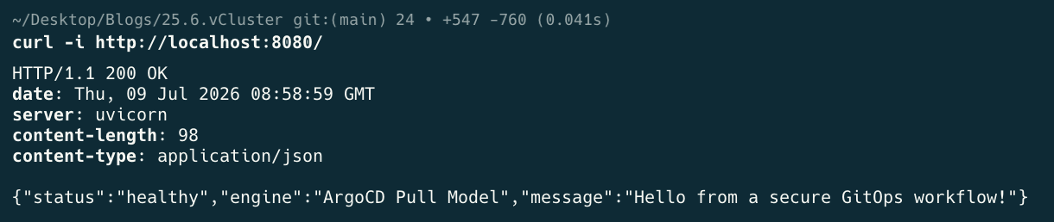

You can also navigate with your browser to go to

- http://localhost:8080/ or
- http://localhost:8080/health/ or
- http://127.0.0.1:8080/ or
- http://127.0.0.1:8080/health

GitHub Runner Compiles: The GitHub Actions workflow detects the code changes, builds a fresh image tagged with the new Git commit SHA, and pushes it to Docker Hub.

GitHub Runner Patches Git: The runner overwrites the image: tag (our placeholder value mentioned previously) inside k8s/deployment.yaml with the new Git SHA and commits it back to the repository.

ArgoCD Detects the updated manifest in Git, pulls down the new declaration, and coordinates a safe, zero-downtime rolling deployment upgrade within your cluster's app namespace.

To access our ArgoCD Management Console:

Default Username and password: admin

ArgoCD creates a random password during installation. This can be retrieved using the below command.

kubectl -n argocd get secret argocd-initial-admin-secret -o jsonpath="{.data.password}" | base64 -d

Now to Access the Console we first need to configure a port-forward (note we’re using 8081 for this as we previously above already utilised 8080):

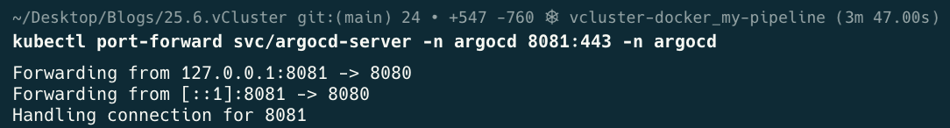
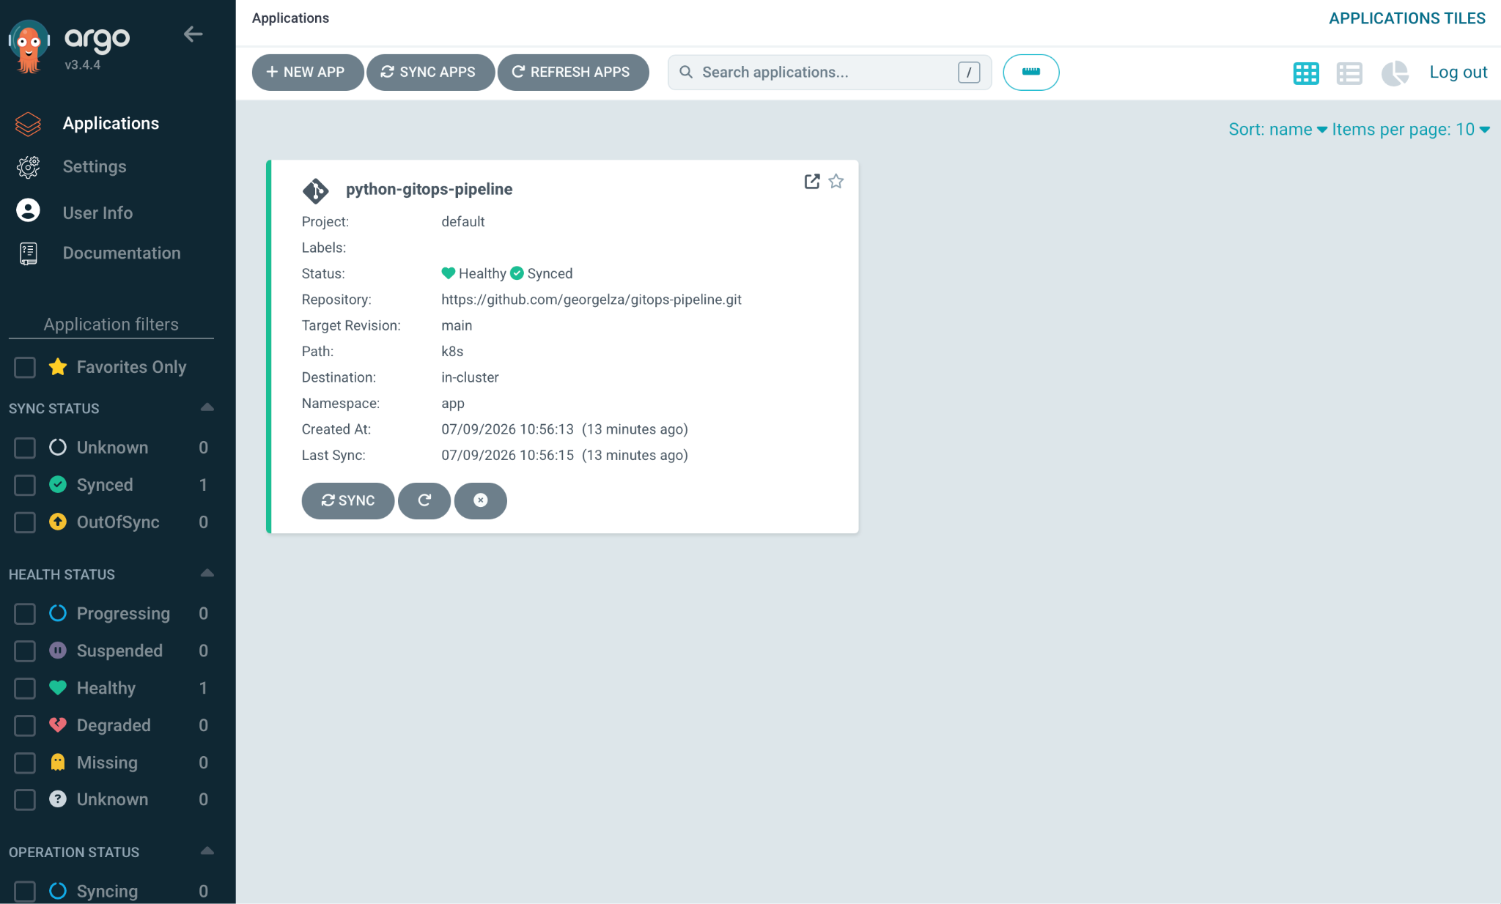

NOTE: Because we're working on our project locally and Github actions is also modifying our k8s/deployment.yml you will be getting the below error stack:

git add .
git commit -m "<comment>"
git push

Results in:

To https://github.com/georgelza/gitops-pipeline.git
! [rejected] main -> main (fetch first)
error: failed to push some refs to 'https://github.com/georgelza/gitops-pipeline.git'
hint: Updates were rejected because the remote contains work that you do not
hint: have locally. This is usually caused by another repository pushing to
hint: the same ref. If you want to integrate the remote changes, use
hint: 'git pull' before pushing again.
hint: See the 'Note about fast-forwards' in 'git push --help' for details.

FIX:

#git add <specify specific file>
git add GITOPS_README.md
git commit -m "<comment>"
git pull origin main
git config pull.rebase false
git push origin main

Summary

Well, I could try and write a long summary here, but, that was it, really very simple. All enabled on our local desktop/laptop by running a Kubernetes cluster inside vCluster .

